## CVWO assignment -- E0543479 Chang Chuan Hao

## Basic Use Cases

* CRUD Tasks and Categories, each task belongs to a category to allow browse by category

## Execution plan

**Deployment:**

* To be deployed on heroku, Rails back end as root dir “task-api”, React root nested in rails dir as “task-app”. Run “npm init –y” and “yarn install” to create package.json and yarn.lock for heroku to install react/yarn dependencies
* Development environment x64 windows 10 build 18363, might need npm install cross-env to resolve linux commands

**Rails:**

* Rails api with --api, React frontend nested within rails root
* generate models, controllers for Task, Category
* Task schema: {title: string, category: belongs_to, done: boolean}
* Category schema: {name: string, task: has_many}
* Communication with front end via jsonapi
* Reconfigure port to 4000 in puma.rb for easier deployment

**React:**

* Initialize with create-react-app
* React-bootstrap to create Navbar elements
* React-router-dom to handle routing in react front end
* Axios to handle communication with backend
* Paths to be created:
  1. ‘/’ root: welcome page
  2. ‘/categories’ categories index: view all categories
  3. ‘/categories/new’ and ‘categories/update/:id’ Create/Update category page
  4. ‘/categories/:id’ Index of all tasks under category of id “:id”
  5. ‘/tasks/’ Index of all tasks
  6. ‘/tasks/update/:id’ and ‘/tasks/new’ Create/Update task page

## Error log

* psql fe_sendauth: no password supplied in “rails server”
  1. No solutions found, sql server changed to sqlite3 for development
* “Implement a tagging system to organise your tasks so that they are easy to search for” unclear – search as in regex/ransack vs category system?
  1. Interpreted as category system – common to-do apps do not include search functions but include category system
* “PORT not recognized error” in “heroku local –f Procfile.dev”
  1. npm install cross-env
  2. Procfile.dev: web: **cross-env** PORT=3000 yarn --cwd task-app start
* “cannot resolve module babel-loader” in “heroku local –f Procfile.dev”
  1. Tried “npm install babel-loader –save”, FAILED
  2. “npm install” on admin cmd prompt, succeeded
* “yarn: not found” in heroku nodejs deployment
  1. “npm init –y”
  2. “yarn install”
* Axios.then executing before rails back end completes request
  1. ~~Possibly remedied if redux was used instead~~
  2. ~~While loop to verify back end up to date before redirecting. Removed since website became much more sluggish~~
  3. Seems to be solved by making onclick async with await on axios before redirecting

## Proof of installation

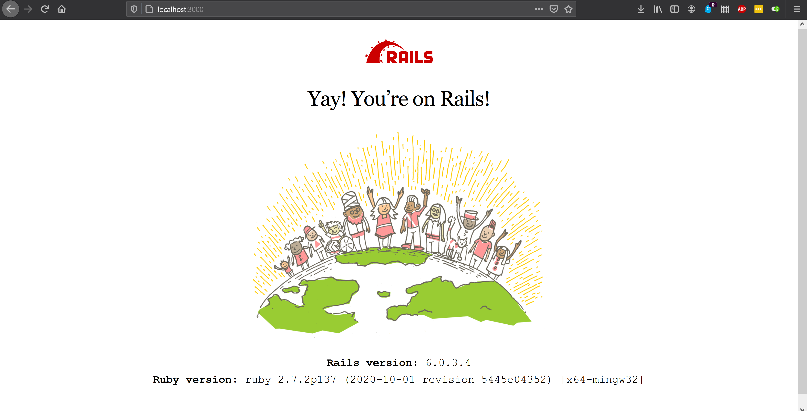

## Suggestions

* Provide more practical guides on react/ rails
* Illustrate ideal end product better:
  1. guides only teach rails/react exclusively, no mention of front/back end integration
  2. “Implement a tagging system to organise your tasks so that they are easy to search for” – search as in search bar or indexing

## Accomplishments

* Feelings ambiguous. Task objectives were ambiguous to begin with, tutorials/ guides available tend to be advocating copy pasting without much explanation of implementation details/ working mechanisms. Much of what was learnt was through trial and error. While the finished product definitely feels like a great accomplishment, it seems with the amount of effort and troubleshooting done a much more interesting product could be made had there been better resources to guide volunteers. Perhaps more guidance could be given to jump start the learning process for future iterations of said assignment.

## User Manual

* Navigate to <https://cvwo-task-manager.herokuapp.com/>
* Create Task
  1. Click on create new task under “View all tasks”
     + Alternatively, under “Find by Categories 🡪 view category” to create a task within specific category
  2. Type in title of task, choose category (“General” by default), then click save
* View Tasks
  1. From Index: click “view all tasks”
  2. From navbar: click the “≡” button on the top right hand corner. Click “Tasks”
  3. Find by categories: under “/categories”, click view on the selected categories. Only tasks under the chosen category will be displayed
* Update task
  1. Click edit on the task you wish to edit
* Delete task
  1. Click delete on the task you wish to delete
* Create Category
  1. Navigate to “/categories” by clicking on “Find by categories” in the home screen or “categories” in the navbar
  2. Click create new category
  3. Type in the name of the category, click save
* Update/Delete Categories
  1. Similar to tasks, done under “/categories”
  2. NOTE: deleting a category deletes ALL tasks under said category. This was done so users can delete an entire set of tasks in one go, e.g. after finishing a module, after graduating etc.
  3. NOTE: “General” category cannot be edited or deleted. This was done so all tasks will have a category to default to, in order to ensure homogeneity of data.

## Proof of final product

